**Vehicle Accident Alert Solution**

# Description

Vehicle Accident Alert is a system that uses a device installed in a vehicle to automatically deliver an alerting message to emergency and relief groups along with the time and location of an accident. They will therefore be able to react to the accident and help the victim swiftly. This solution was chosen because AWS IoT enables MQTT communication between Internet-connected, in-vehicle embedded devices and the AWS cloud.

The main purpose of this project is to monitor the driver's speed and send a location and alert message to the accident's registered email address, phone number, and emergency numbers in order to provide immediate aid and save lives if an accident happens.

**Business Function**

New technologies in the vehicle industry are constantly resulting in the addition of new features to automobiles in order to minimize traffic accidents and boost safety. Furthermore, the growing number of fast-moving cars on the road, as well as the construction of motorways and expressways, is boosting the demand for safety systems such as vehicle accident alert systems and driver alert warning systems. As a result, increased customer awareness is prompting automakers to implement a safety system that will improve the car accident alert system.

**Target Audience**

**Emergency Providers**Road accidents happen every day and cause a significant amount of deaths and injuries. The bulk of fatalities stem from people responding slowly to these emergencies. The first hour after a serious injury is referred to as the "golden hour" because receiving critical medical and surgical care at that time increases the probability of saving lives by an average of one-third.

The use of an accident detection and reporting system is crucial for this strategy. In such a situation, the emergency services are instantly alerted of an accident. As a consequence, the injured accident victims will receive quick assistance.

**Automakers**The manufacturer's recognition of a rising market requirement to enhance the functional aspects of their driver warning systems, such as why the automobile was involved in the accident at that particular location, what brought about the vehicle to be in that position, etc., is also implied by this.

Despite the fact that a lot of people are working on this technology, it could not be perfect or have insufficient financing. The companies who build the cars are ultimately in charge of enhancing their functional components, and they may include a sensor that would yield superior results.

**Justification**

Accidents are occurring at an alarming rate these days. The use of vehicles such as automobiles and motorcycles is expanding as a result of increased employment. And the majority of the collisions were caused by excessive speed. People are being put in danger as a result of their excessive speed. Most of the time, the sufferer does not receive assistance in a timely manner since no one is aware of the mishap.

This project presents an optimal way to decrease such accidents. A car accident detection and alerting system based on the Internet of Things is unveiled. The primary goal is to give immediate assistance and save lives by sending a location and alert message to the registered email address, mobile phone number, and emergency numbers if the accident is serious.

By warning the driver if they are above the 70 mph limit, this project hopes to reduce accidents by taking preventive measures. Numerous studies have shown that when the speed rises, automobile collisions also have terrible consequences. An automobile moving slowly has a 1% chance of causing a serious accident. At 50 km / h, the probability of being hurt climbs to 69 percent, and the danger of being seriously hurt rises to 52 percent. When an automobile is traveling at speeds of at least 100 km/h, a deadly collision is almost a given.

IoT-connected cars, such as in, transmit automated SOS signals to emergency services in the event of an emergency due to unanticipated circumstances, aiding in delivering timely treatment and lowering accident-related fatality rates. This development will result in measures that will reduce road congestion, avoid accidents, and give aid even in distant areas.

As a result of this method, near-by cars will be alerted to the location of the collision. They have the option of avoiding the accident location in order to avoid being involved in a risk of an accident that may cost them money and threaten their lives. Finally, it is up to the driver's desire to assist the accident-prone car, as the solution's primary goal is to save valuable lives.

**Chart of Singapore vehicle accidents**

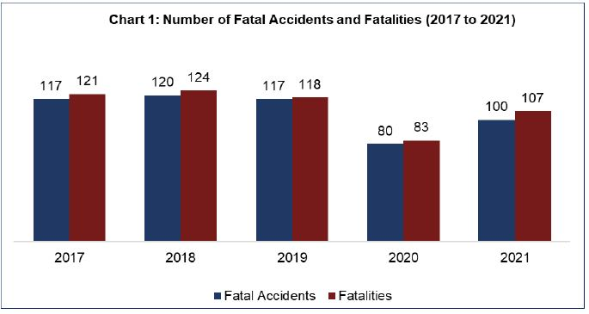

**Scope  
  
Cloud 9**

To imitate the Raspberry Pi hardware, AWS Cloud9 will employ a cloud-based integrated development environment (IDE). It will be used to initiate and publish Real-Time Data Transfer to IOT Core using MQTT Test Client Protocol

via the subject "alert” & “speed”.

**AWS IoT Core**AWS IoT Core allows you to connect devices to AWS Services and other devices, protect data and interactions, process, and act on device data, and communicate with devices through apps. In this regard, AWS IoT allows MQTT communication between Internet-connected vehicle-embedded devices and the AWS cloud.

AWS IoT Core will be used to connect to the Cloud9 service using the MQTT protocol, as authenticated by the IoT Things certificates and endpoints.

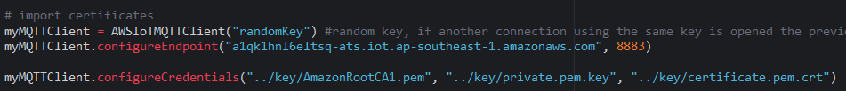

**AWS SNS**

In AWS SNS, users may subscribe to topics and receive notifications when a publisher publishes to certain topics. AWS SNS is used in this project to send an email to a party that is involved, and Real-time Framework manages real-time interactions.

The sensor will take preventive measures by sending notifications if the driver is going beyond the speed limit of 70/hr.

If crash impact is detected, the details of the collision, including the longitude and latitude of the accident's position on a google map, the phone numbers of the emergency services involved, the car numbers, and the timestamp of the event are sent by email to a person who was involved using AWS SNS.

**DynamoDB**

Data structures and key-valued cloud services are made possible by DynamoDB, a database system offered by Amazon Web Services. In this instance, the accident information, including the car number, time, latitude, and longitude, is recorded using DynamoDB. The lambda code would produce and store accident data in DynamoDB, including the car number, date, latitude, and longitude.

**IAM**

IAM allows you to designate who has access to which services and resources and under what restrictions. To simulate an automobile collision, a new IAM role would be established just for this project. This user would be assigned the appropriate permissions and policies.

A new IAM user (carCrashUser) was created for this project. The user would be assigned the appropriate permissions and policies.

**Lambda**

AWS Lambda gives you the ability to simply add custom logic to AWS resources like Amazon S3 buckets and Amazon DynamoDB tables, enabling you to apply computation to data as it enters or moves across the cloud.  
  
For this project, AWS Lambda acts as the manager, calling the features of the used services. The lambda function will be called in response to the IoT Core trigger, transmitting the accident information, such as the car number. The function will then be activated by sending an email to the relevant SNS topic and saving the information in the DynamoDB and S3 buckets.

**CloudWatch**

You may use your current system, application, and custom log files to monitor and troubleshoot your systems and applications with Amazon CloudWatch Logs. You may monitor your logs using CloudWatch Logs in almost real-time for particular words, numbers, or patterns. In order to complete this project, CloudWatch Logs must guarantee that the answer is forwarded to DynamoDB, SNS, and S3.

**S3**

Any quantity of data may be stored and accessed from anywhere with Amazon S3, an object storage system. For this project, an S3 bucket is made to serve as a repository for Amazon S3 objects. The lambda function for this project would also cause the storage of a CSV file containing accident data in an S3 bucket.

**System Architecture**

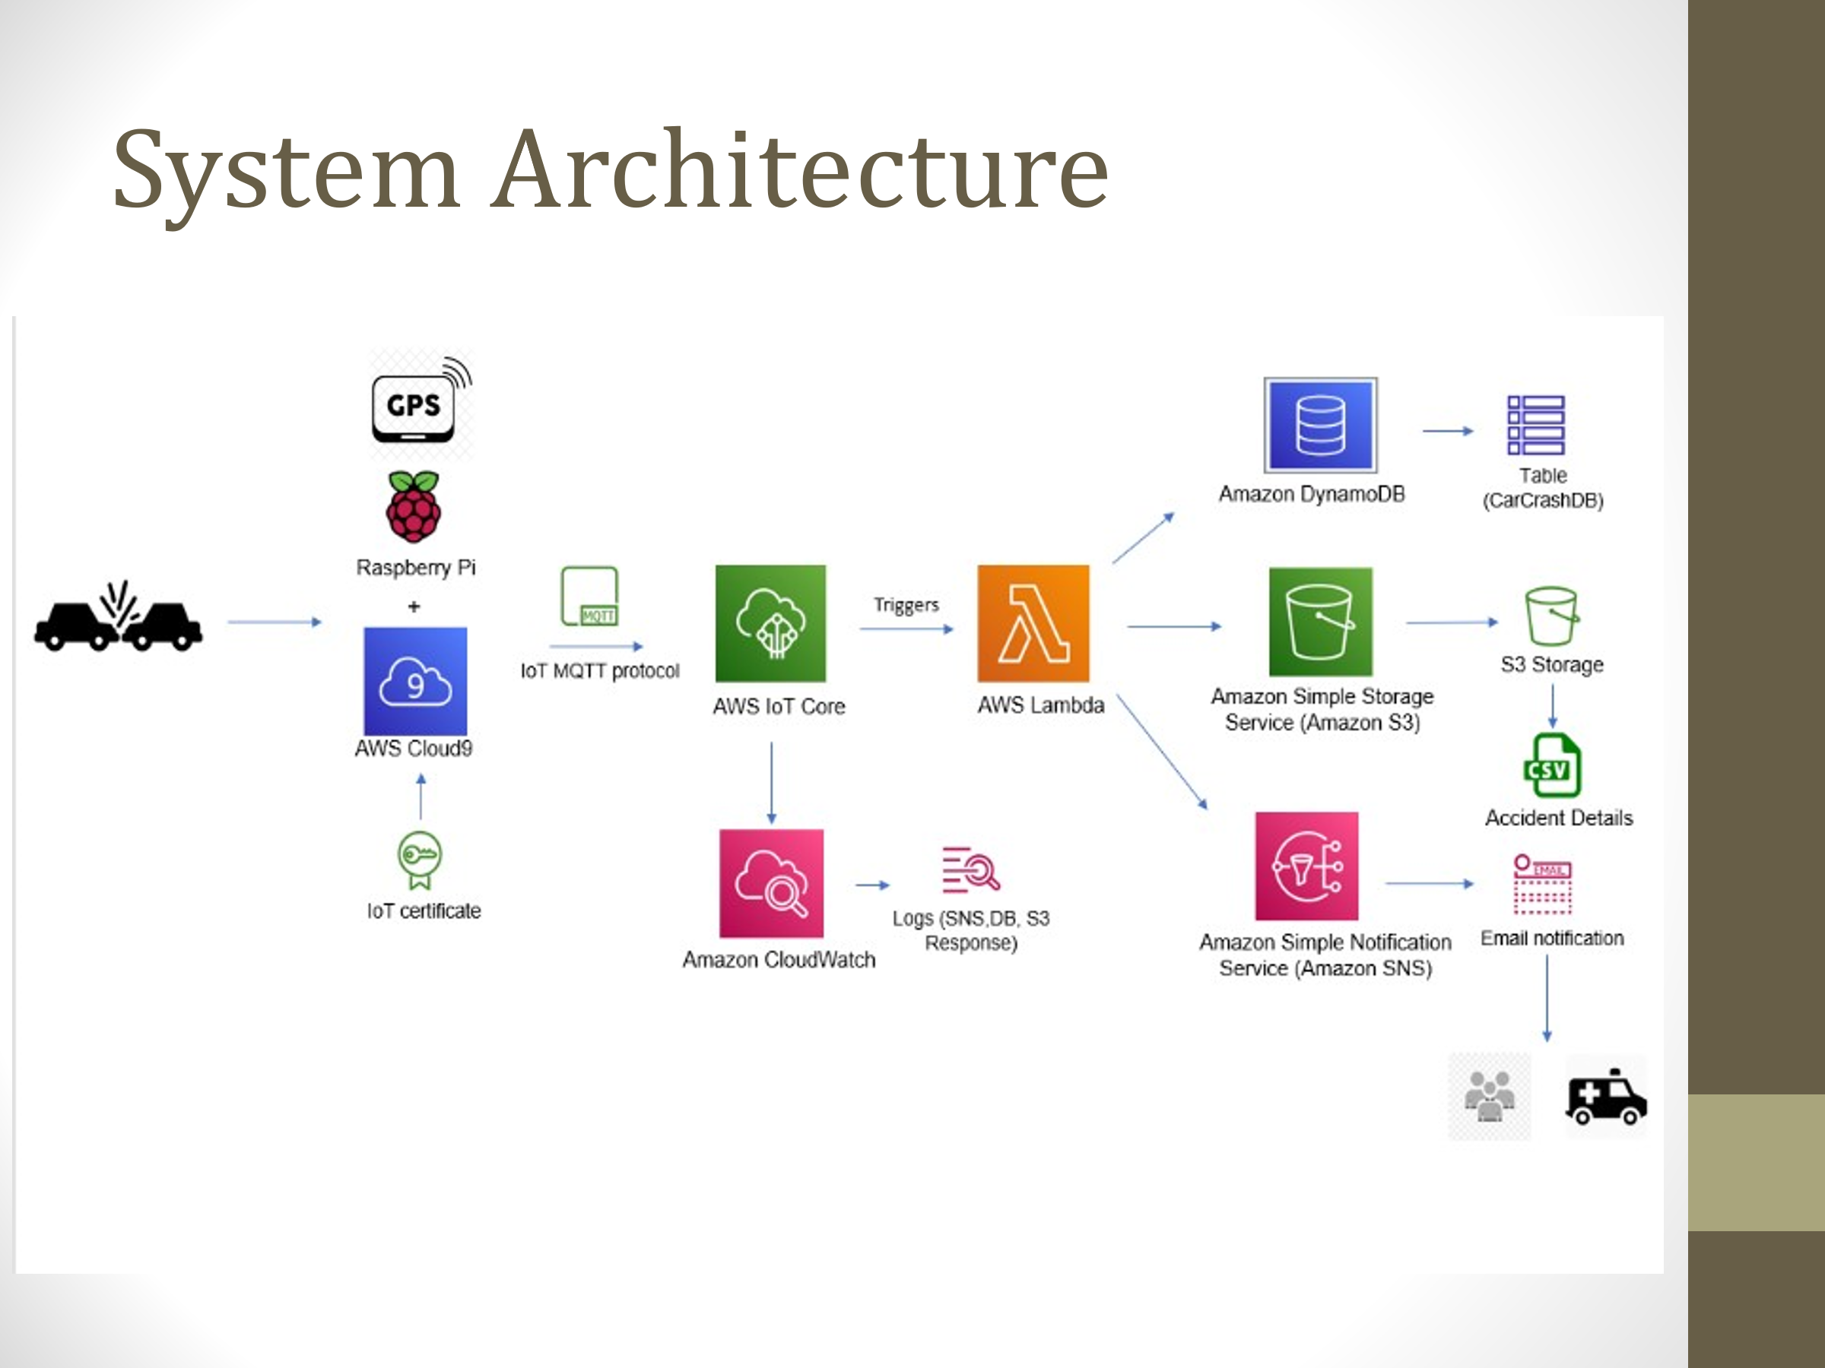

**References**

* <https://www.ijert.org/nb-iot-based-road-accident-alert-system>
* <https://www.ijres.org/papers/Volume-9/Issue-5/Ser-5/L09056972.pdf>
* <https://www.ncbi.nlm.nih.gov/pmc/articles/PMC8541234/>